Sight-reading is a skill of immense importance. It is often under-valued by teachers and students alike, but if worked at consistently, it’s arguably the most useful tool in a musician’s toolbox. If a musician can read well, the whole learning process is made that much easier and quicker, and the possibilities and capacity for ensemble playing of all kinds are enormous.
Another facet which can cause unnecessary worry when learning to sight-read is the ever-present problem of wrong notes and errors. To attain a high level of accuracy and speed when reading, mistakes are essential! It’s really just part of development and growth, so playing inaccurately should not be viewed negatively; quite the contrary, because much experimentation is required when learning to read. If sight-reading can be viewed as an enjoyable (and even fun) part of a practicing regime, improvement will be that much quicker.

Scanning Ahead
When encountering new music, you should work on training yourself to first scan ahead for parameters such as key signature, accidentals, and tricky rhythms using the acronym S.T.A.R.S. to remember these items:
- Signatures (time and key): How many beats per measure? What notes in this line are affected by the key signature?
- Tempo (and other expressive markings): How fast and with what character should the music be played?
- Accidentals: Where do they occur and for how long before returning to the “normal” (diatonic) note(s)?
- Rhythms: Are there any complex rhythms that should be examined? How should the rhythmic subdivisions be counted?
- Signs (repeats, endings, segno, coda, etc.): What is the “roadmap” for this piece?

Below is a real example from the sight-reading generator on Thursday.
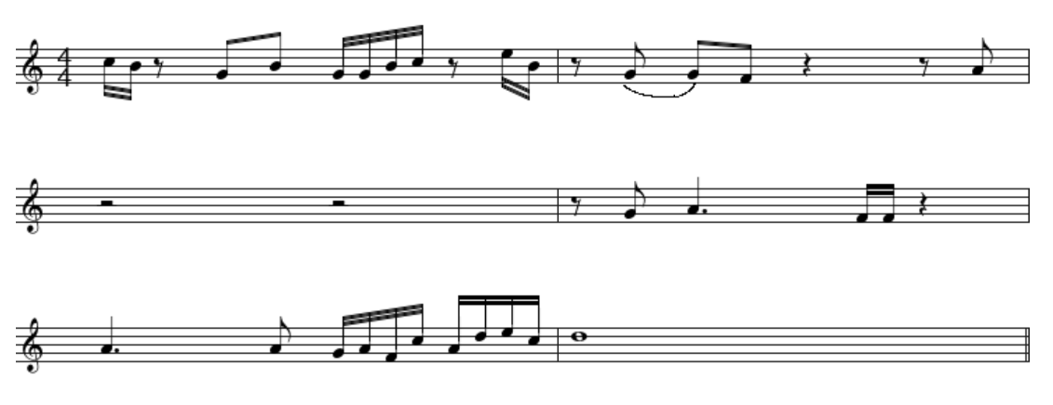
While there are no tempo markings or dynamics to look for, I would look for the key & time signature (in red). Look for any tricky passages for fingers or slides (Blue) or any tricky rhythms / rests (green) and try to sort them out before you start.
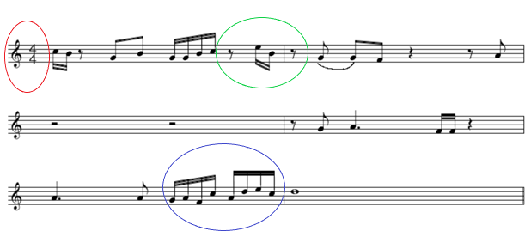
Suggestions for things that will help you get better at sight-reading:
- Learning your major scales
- Learning the key signatures for each major key (if a challenge is needed, learn the minors too
- Use the https://practicesightreading.com/ rhythm generator to generate different rhythms to clap out
- Try reading different styles of music on your instrument. There are plenty of different compositions and arrangements on www.musescore.com
- Don’t forget the rests. So often, when students sight-read music they shortchange or go right past rests. If its less than one bar, you need to count it out for sure!

